Lab53:
Indexes:
Clustered Index:
A clustered index sorts and stores the data rows in the table or view based on the key values. Each table can have only one clustered index because the data rows themselves can be sorted in only one order.
e.g.
Creating a clustered index on the Employee table using the EmployeeID column.
This script creates a clustered index named IDX_EmployeeID on the EmployeeID column of the Employee table.

Non-Clustered Index:
A non-clustered index creates a separate structure to hold the index and pointers to the actual data rows in the table. A table can have multiple non-clustered indexes.
e.g.
This script creates a non-clustered index named IDX_EmpName on the EmpName column of the Employee table.

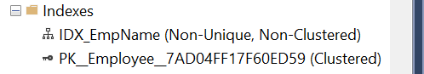

Unique Index:
A unique index ensures that the indexed column(s) contain unique values, preventing duplicate entries.
E.g.
Creating a unique index on the PhoneNumber column of the Employee_Personal_Info table.
This script creates a unique index named IDX_UniquePhoneNumber on the PhoneNumber column of the Employee_Personal_Info table. Ensures PhoneNumber column is unique.
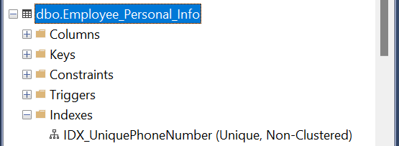

Filtered Index:
A filtered index is a non-clustered index with a filter predicate, which allows you to index a subset of rows in the table.
e.g.
Creating a filtered index on the Employee table for employees with a salary greater than 50000.
This script creates a filtered index named IDX_FilteredEmpSalary on the EmpSalary column of the Employee table.
It includes only rows where EmpSalary is greater than 50000, improving query performance for this subset of data.
